LL/LR Parsers

🧠 What Are LL and LR Parsers?
# Source: AI Source: Provided by: [Data Path: Persons Table -> ID Column: 1, Name_En Column: Motasem Essam] -> From: [Chatgpt (GPT‑5 Mini)] on [12/9/2025]
LL and LR parsers are two major types of syntax parsers used in compiler design to analyze programming languages. They both check whether a sequence of tokens (like code) matches the grammar of a language — but they do it in different directions and styles.

🔹 What They Do:
# Source: AI Source: Provided by: [Data Path: Persons Table -> ID Column: 1, Name_En Column: Motasem Essam] -> From: [Chatgpt (GPT‑5 Mini)] on [12/9/2025]
LL and LR parsers convert a stream of tokens (from a lexer) into a syntax tree by checking grammar rules.

🔍 LL Parser
# Source: AI Source: Provided by: [Data Path: Persons Table -> ID Column: 1, Name_En Column: Motasem Essam] -> From: [Chatgpt (GPT‑5 Mini)] on [12/9/2025]
- L: Left-to-right scanning of input
- L: Produces a Leftmost derivation

➕ Characteristics:
# Source: AI Source: Provided by: [Data Path: Persons Table -> ID Column: 1, Name_En Column: Motasem Essam] -> From: [Chatgpt (GPT‑5 Mini)] on [12/9/2025]
- Top-down parsing
- Starts from the start symbol and tries to rewrite it into the input
- Easy to write by hand (used in simple recursive-descent parsers)
- Requires grammar to be LL(k) — predictable based on k lookahead tokens

🧩 Example Tools:
# Source: AI Source: Provided by: [Data Path: Persons Table -> ID Column: 1, Name_En Column: Motasem Essam] -> From: [Chatgpt (GPT‑5 Mini)] on [12/9/2025]
- ANTLR (modern)
- Recursive-descent parsers
- JavaScript's PEG.js

🔍 LR Parser
# Source: AI Source: Provided by: [Data Path: Persons Table -> ID Column: 1, Name_En Column: Motasem Essam] -> From: [Chatgpt (GPT‑5 Mini)] on [12/9/2025]
- L: Left-to-right scanning of input
- R: Produces a Rightmost derivation in reverse

➕ Characteristics:
# Source: AI Source: Provided by: [Data Path: Persons Table -> ID Column: 1, Name_En Column: Motasem Essam] -> From: [Chatgpt (GPT‑5 Mini)] on [12/9/2025]
- Bottom-up parsing
- Starts from the input tokens and tries to reduce them to the start symbol
- Handles more complex grammars than LL parsers
- Often used in real compilers like GCC, JavaC

🧩 Example Tools:
# Source: AI Source: Provided by: [Data Path: Persons Table -> ID Column: 1, Name_En Column: Motasem Essam] -> From: [Chatgpt (GPT‑5 Mini)] on [12/9/2025]
- Yacc, Bison, LALR, SLR generators
- Used in C/C++, Java, Rust compilers

📊 LL vs LR Parser: Key Differences
# Source: AI Source: Provided by: [Data Path: Persons Table -> ID Column: 1, Name_En Column: Motasem Essam] -> From: [Chatgpt (GPT‑5 Mini)] on [12/9/2025]
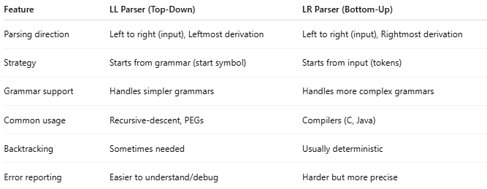

Feature | LL Parser (Top-Down) | LR Parser (Bottom-Up)
Parsing direction | Left to right (input), Leftmost derivation | Left to right (input), Rightmost derivation
Strategy | Starts from grammar (start symbol) | Starts from input (tokens)
Grammar support | Handles simpler grammars | Handles more complex grammars
Common usage | Recursive-descent, PEGs | Compilers (C, Java)
Backtracking | Sometimes needed | Usually deterministic
Error reporting | Easier to understand/debug | Harder but more precise

visual step-by-step demo
Great! Let's do a visual step-by-step demo of both LL (top-down) and LR (bottom-up) parsing using a simple grammar and input.

🎯 Goal:
We’ll parse this input string:
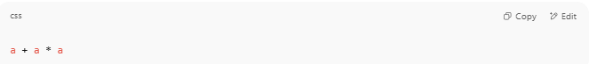
a + a * a

Using this simplified grammar (like part of arithmetic):
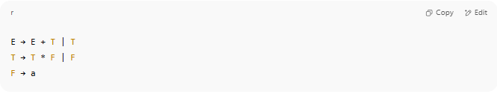
E → E + T | T
T → T * F | F
F → a

🔁 Rewrite: Remove Left Recursion (for LL parser)
To make it LL-friendly, we rewrite the grammar:
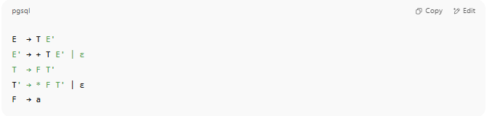
E → T E'
E' → + T E' | ε
T → F T'
T' → * F T' | ε
F → a

Now we can proceed with both types of parsers.

👁️ LL Parser Demo (Top-Down Parsing)
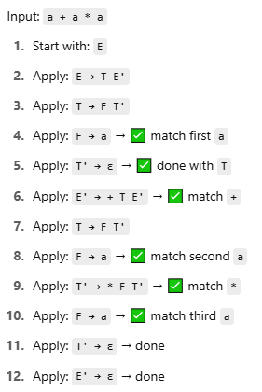
Input: a + a * a
- Start with: E
- Apply: E → T E'
- Apply: T → F T'
- Apply: F → a → ✅ match first a
- Apply: T' → ε → ✅ done with T
- Apply: E' → + T E' → ✅ match +
- Apply: T → F T'
- Apply: F → a → ✅ match second a
- Apply: T' → * F T' → ✅ match *
- Apply: F → a → ✅ match third a
- Apply: T' → ε → done
- Apply: E' → ε → done
✅ Successfully parsed: a + a * a
LL parser does this using recursive calls matching rules from left to right.

⚙️ LR Parser Demo (Bottom-Up Parsing)
Input: a + a * a
We shift symbols onto a stack and reduce when they match a rule.
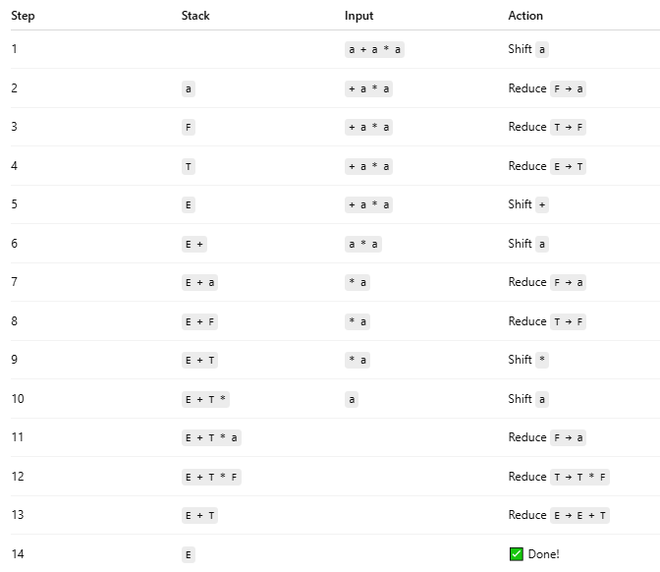
Step | Stack | Input | Action
1 |  | a + a * a | Shift a
2 | a | + a * a | Reduce F → a
3 | F | + a * a | Reduce T → F
4 | T | + a * a | Reduce E → T
5 | E | + a * a | Shift +
6 | E + | a * a | Shift a
7 | E + a | * a | Reduce F → a
8 | E + F | * a | Reduce T → F
9 | E + T | * a | Shift *
10 | E + T * | a | Shift a
11 | E + T * a |  | Reduce F → a
12 | E + T * F |  | Reduce T → T * F
13 | E + T |  | Reduce E → E + T
14 | E |  | ✅ Done!
LR parser works bottom-up, starting from terminals and reducing to higher-level rules.

🧠 Summary:
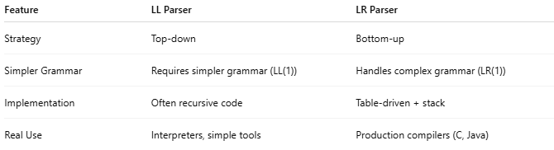

Feature | LL Parser | LR Parser
Strategy | Top-down | Bottom-up
Simpler Grammar | Requires simpler grammar (LL(1)) | Handles complex grammar (LR(1))
Implementation | Often recursive code | Table-driven + stack
Real Use | Interpreters, simple tools | Production compilers (C, Java)

🔧 Why Use Them?
# Source: AI Source: Provided by: [Data Path: Persons Table -> ID Column: 1, Name_En Column: Motasem Essam] -> From: [Chatgpt (GPT‑5 Mini)] on [12/9/2025]
- They power compilers, interpreters, and language tools
- Help convert code into an Abstract Syntax Tree (AST) or executable instructions
- Ensure source code follows the grammar rules of a programming language

✅ Summary
# Source: AI Source: Provided by: [Data Path: Persons Table -> ID Column: 1, Name_En Column: Motasem Essam] -> From: [Chatgpt (GPT‑5 Mini)] on [12/9/2025]
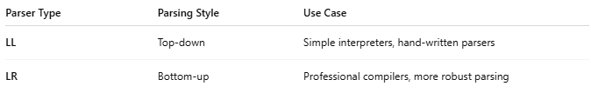
Parser Type | Parsing Style | Use Case
LL | Top-down | Simple interpreters, hand-written parsers
LR | Bottom-up | Professional compilers, more robust parsing

Would you like a visual demo of how LL or LR parsing works step by step, or want to try writing one in Python or JavaScript?

